**Day 1 Assignment 1**

Draw your home network topology and explain how you are accessing the RPS lab Environment

HOME NETWORK

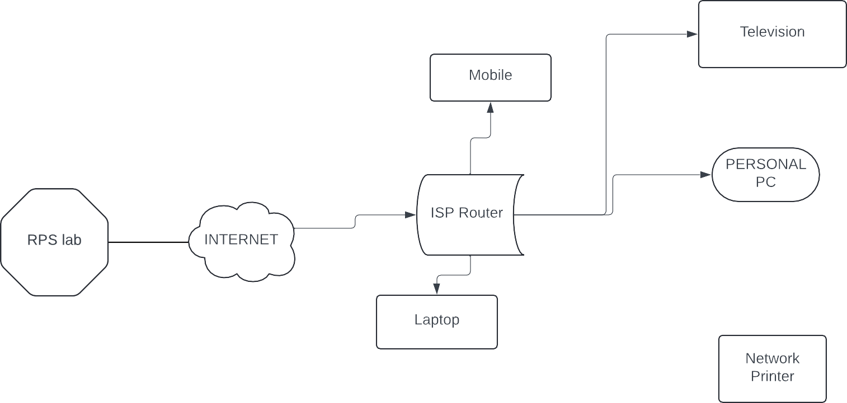

* The RPS Lab Environment is accessible externally from our system via the Outside Network. The Internet serves as the conduit between our home network and external data sources not directly hosted on our personal devices.
* **ISP** : Internet Service Provider providing the internet connection.
* **Router** : Central hub of the home network.
* **RPS CLOUD ENVIRONMENT** : Remote Processing System lab environment accessed through VPN for remote experimentation and tasks.The RPS Lab Environment is accessed through a VPN for remote experimentation and tasks.

**Day 2 Assignment : 2**

Identify a real-world application for both parallel computing and networked systems. Explain how these technologies are used and why they are important in that context.

* **A real-world applications of parallel computing and networked systems using the example of movie production.**

**1.Parallel Computing in Movie Rendering :**

**APPLICATION** : Rendering complex CGI (Computer Generated Imagery) scenes in movies requires massive computational power. Parallel computing is crucial in this context to accelerate the rendering process.

**HOW IT’S USED** : Movie studios use parallel computing techniques to distribute rendering tasks across multiple processors or computers, enabling them to render frames simultaneously rather than sequentially.

**Importance** : Parallel computing significantly reduces the time required for rendering high-quality CGI scenes, which is essential for meeting tight production deadlines in the film industry. For example, Pixar Animation Studios utilizes parallel computing to render intricate scenes in movies like "Toy Story" or "Finding Nemo," ensuring stunning visual effects within reasonable production schedules.

**Networked System for Collaborative Movie Production :**

**APPLICATION** : Movie production involves collaboration among various teams, including directors, editors, visual effects artists, and sound engineers, often located in different geographical locations.

**HOW IT’S USED:** Networked systems facilitate seamless collaboration by providing tools for file sharing, real-time communication, and version control. For instance, cloud-based platforms like Google Drive or Dropbox allow teams to share and edit project files, while video conferencing tools like Zoom or Skype enable remote meetings and discussions.

Importance : Networked systems enhance efficiency and productivity by enabling smooth communication and collaboration among distributed teams. They ensure that all stakeholders have access to the latest project files and can provide timely feedback, thereby streamlining the movie production process. A notable example is the production of "The Lord of the Rings" trilogy, where director Peter Jackson and his team utilized networked systems for remote collaboration between filming locations in New Zealand and post-production facilities around the world.

In summary, parallel computing and networked systems play crucial roles in movie production by accelerating rendering tasks and facilitating collaborative work among geographically dispersed teams. These technologies are essential for delivering high-quality movies within demanding production schedules while fostering creativity and innovation in the film making process.